# Bill of Quantities (BoQ) – Bullet Resistant & Security Steel Door

|  |  |  |  |  |
| --- | --- | --- | --- | --- |
| Sl. No. | Description | Unit | Qty | Remarks |
| 1 | Bullet Resistant & Security Steel Door – comprising the following specifications:  Core: Proprietary ballistic core complying with UL 752 – Level 8 (FB6 Equivalent), NIJ 0108.01 – Level III, ASTM F1233-98 – Class IV Forced Entry Protection and EN 1627:2011 – RC3 Security Resistance Class.  Construction: Door leaf & frame fabricated from 3 mm GI sheet, filled with proprietary ballistic infill, additional reinforcement for anti-vandalism, equipped with 3-point multi-locking system and heavy-duty hinges.  Finish: Factory-finished with Epoxy-Polyester Powder Coating / PU Painted (shade as approved by Engineer/Client).  Performance: Provides ballistic protection against 7.62 mm rifle ammunition (UL 752 Level 8 / NIJ Level III) and burglary protection as per ASTM F1233-98 Class IV and EN 1627 RC3 standards. | Sqm | As required | Supply, installation & commissioning complete in all respects |

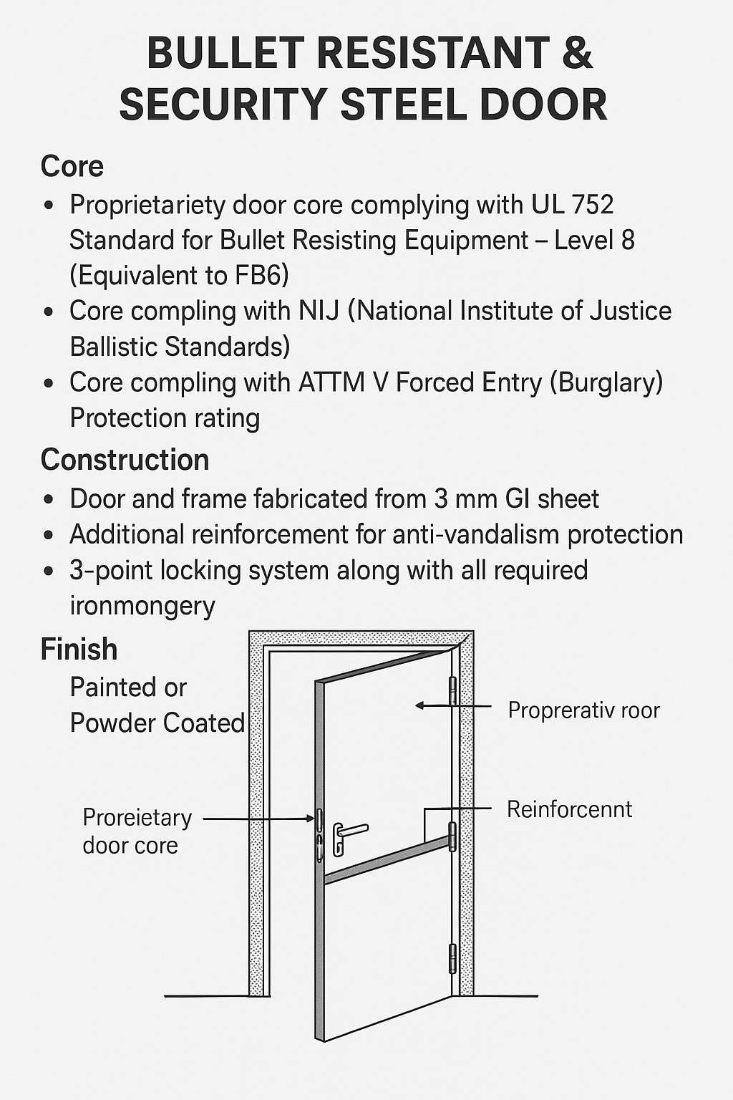

**RC3 for Doors – Explained from the Source**

Based on the page from Sehgal Doors, **RC3** refers to a **Resistance Class 3** rating for security doors. Here's what it means in context:

### What RC3 Doors Are

* **RC3-rated doors** are designed to resist **forced entry attempts** by experienced intruders.
* These attackers may use **simple tools** like crowbars, screwdrivers, or pliers, and apply **leverage techniques** to break in.

### Testing & Standards

* RC3 doors are tested under the **SN EN 1627–1630 European standards**, which assess resistance against burglary.
* During testing:
  + The door must withstand **5 minutes of active attack**.
  + The total test duration is **20 minutes**, including preparation and setup.

### Where They're Used

* Ideal for **high-security environments**, such as:
  + Upscale residential buildings
  + Business divisions
  + Electronic data processing (EDP) systems
  + Banks and financial institutions

So, RC3 doors strike a balance between robust protection and practical usability, making them a smart choice for areas that require elevated security without going full fortress mode.